Demystifying and Simplifying Baroque and Classical Ornamentation

A Workshop by Annette Farrington
for the Rochester Flute Association Flute Fair
Saturday, October 21, 2023

Good performance is the ability to bring out the true content and affect of a piece:
the details of beauty.
C. P. E. Bach

For that which does not come from the heart does not easily reach the heart.
Johann Joachim Quantz

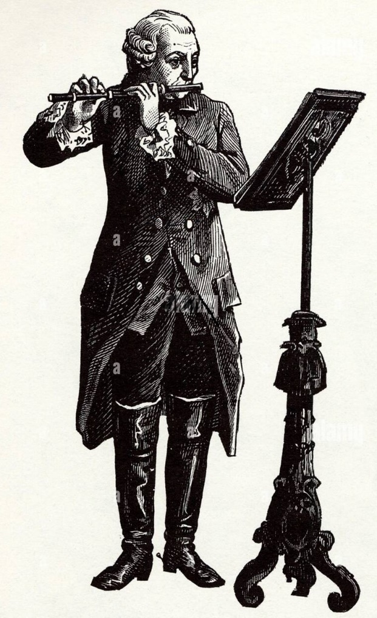

Baroque and Classical periods are defined as music (mostly European) written between 1600 – 1827. There is a vast library of repertoire for the flute from these periods. Performing this music can be a delight or a chore depending on the flutist’s understanding of how to interpret the printed score. Much of what was intended is not written down—at least not in the original versions. Audio recording was an invention still more than a century in the making, so we cannot really know how Hotteterre, Quantz, Devienne, Tromlitz and many others interpreted this music. What we do have are excellent treatises offering details into this style: Jacques Hotteterre’s Principes de la Flûte Traversière, ou Flûte d’Allemagne, de la Flûte à Bec, ou Flûte douce, et du Hautbois (1707), J. J. Quantz’s Versuch einer Anweisung die Flöte traversiere zu spielen (1752), J. G. Tromlitz’s Ausführlicher und gründlicher Unterricht die Flüte zu spielen (1791) to name a few. With the rise in Historically Informed Performance Practice mid-20th century, we have a plethora of articles, videos, websites, podcasts, and audio recordings produced by musicians specializing in this music from whom we can learn.

This workshop attempts to synthesize a small portion of this vast library of information so that the student of this music can perform it in a way that is truer to the style, enjoyable to play and hear, and perhaps, set that student on their own journey into exploring the richness of this music.

TONE

- It is not necessary to try to imitate the sound of the one-keyed and simple system flutes on your modern instrument. There is too much difference in their design.
- Producing the best tone on what you play now would satisfy Quantz’s concept of a good flute tone—resembling a contralto with a clear, penetrating, thick, round, and pleasing sound.
- Tromlitz also suggested modeling the human voice—bright, full, and resonant
- Avoid an excessive, wide, or deep vibrato. The way modern vibrato is produced with a vibrating air column (sometimes referred to as “chest vibrato”) was not used.
- Playing with no vibrato at all on the modern flute can sound dull and out of tune. A light shimmer of vibrato combined with volume shadings (messa di voce) will make a convincing performance.

♬ Practice Focus

- Long tones incorporating dynamics, especially crescendo to decrescendo and back.
- “Phrasing Gesture Scales” featured in The Flute Scale Book by Patricia George and Phyllis Louke are excellent for developing strong-weak gestures needed in appoggiaturas.
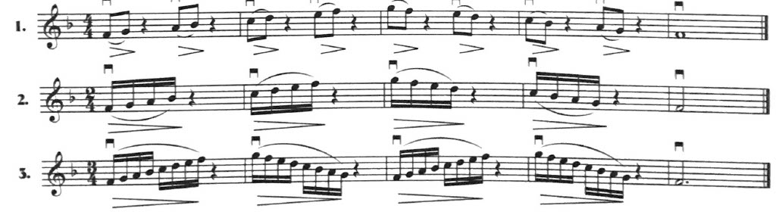

TEMPO

Three factors determine the speed of a movement:

- Time signature (the smaller the denominator, the faster the tempi)
- Tempo and mood markings
- Fastest motion

One has to allow for:
- Variations of acoustics
- Personal temperament
- Current mood

Before the metronome was invented in 1815 such devices as pendulum or one’s heart rate was used as a standard.

Quantz categorized tempo into four classes:
- Allegro assai (includes allegro di molto, Presto, etc.)
- Allegretto (includes Allegro ma non tanto, non troppo, non presto, moderato, etc.)
- Adagio cantabile (includes Cantabile, Arioso, Larghetto, Dolce, etc.)
- Adagio assai (includes Lento, Margo assai, Grave, etc.)

Dance forms such as minuet, gavotte, bourrée, etc. also determined tempo.

♬ Practice Focus

- Use a metronome to establish a steady pulse especially in the slow movements.
- Performance tempo does not have to be rigid, but should have motion. Cadences can be prolonged and harmonic arrival points emphasized.
- Listen to good performances for modeling, then perform the work at a speed at which you can stay in control and be convincing.

ARTICULATION

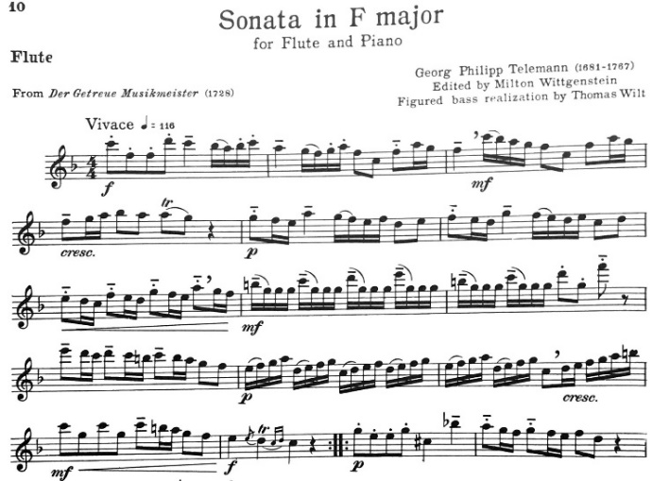
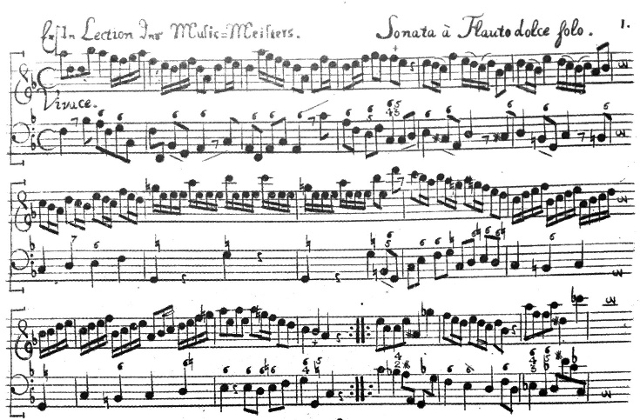
[Facsimile from “Der getreue Musikmeister” [G. Schirmer edition]
as included in the Barenreiter edition]

- Published music of the time had few articulations or dynamic markings.
- Slurs rarely used but can be found to highlight a specific articulation.
- As a general rule, stepwise notes were played in a legato manner, leaps were articulated.
- Inflection and nuance created by using a variety of syllables such as ti, ri, di, and did’ll.

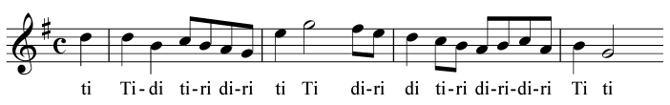

Bourrée anglaise from Handel G major sonata HWV 363b, op.1 no.5.

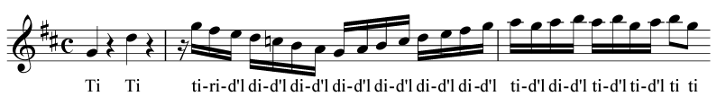
Presto from Handel B minor sonata HWV 376

Slurring for ease of playing was common in this type of pattern found in the second movement of Handel’s G major sonata.

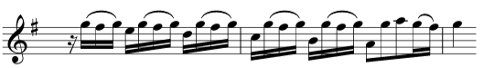

Music of the 1700s is based on the idea of dancing and oration, so the notes should be separated or unglued.

- Applying the best syllable requires an understanding of beat hierarchy. This is the notion that there are strong and weak beats within each bar. An example in 4/4 time would look like

1 2 3 4

A good way to think of this is suggested by Emmanuel Pahud, principal flute of the Berlin Philharmonic: “come away from 1--come away from 3--after 4 lead into 1.”

♬ Practice Focus

- Perfect your double tonguing (du-gu) and add slurs to imitate the effect of the Baroque syllables. (Pairs of slurs, slur 3-tongue 1 or vice versa and whole beats most common)
- Practice groups slowly to control dynamics within the beat.
- Learn to “bounce” your articulated notes by practicing them with a “hah” attack.
- Taffanel & Gaubert knew that flutists needed to be fluent in many articulation patterns, so apply these to your technical routine as suggested in their 17 Big Daily Finger Exercises.
ORNAMENTATION

Two types of ornamentation:

- Those that are written out with symbols such as the trill ( + ) or mordent ( )
- Extempore Ornamentation—adding notes in a harmonic or melodic fashion to increase the expression in the melody most often in slow movements

APPOGGIATURA

Literally means “to lean.” Notated as small grace notes before a main note. They should be played ON the beat and it takes away some of the value of the main note. The small note is played a little louder than the main note—think “strong” “weak.”

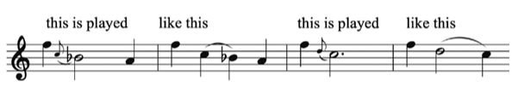

Examples of appoggiatura from Bach’s Sonata in E-flat Major, BWV 1031

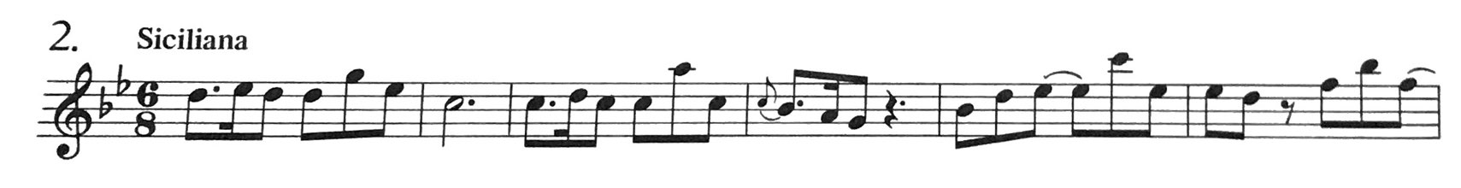
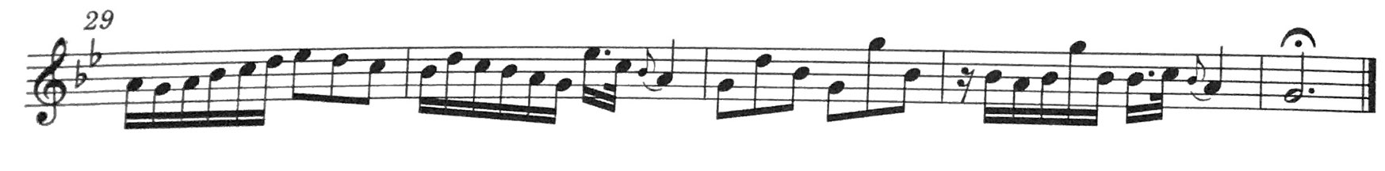

TRILLS

Symbols for trills:
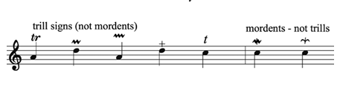
Two types of trills: cadential and ornamental
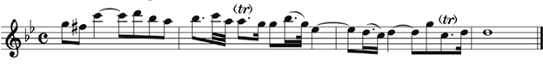
[Handel Sonata in G Minor, Op. 1, No. 2]

General rules to keep in mind:

- The trill starts from the upper note played ON the beat—think appoggiatura!
- Slur this upper note into the main even if not indicated. Tongue the note following the trill to create a clear placement of the resolution.
- Start the trill slowly and increase the speed as you approach the end of its value. Baroque trills should be elegant, not jackhammers.
- The speed of the trill should be in context of the movement—slower movements, slower till and vice versa.
- Short trills still begin on the upper note but there is no time to stress it. The symbol for these may look like a mordent, but it is not the same. Begin the short trill on the beat.
- Ending the trill with a turn makes for smoother transition out of the trill.
- Anticipation of the downbeat the end of the cadence practiced in modern times but not typically the fashion in the 18th century.

MORDENTS/BATTEMENT

Another effective ornament to add is the mordent (Latin: to bite). Also known in the French as battement or pincé. There were several ways of notating a mordent:

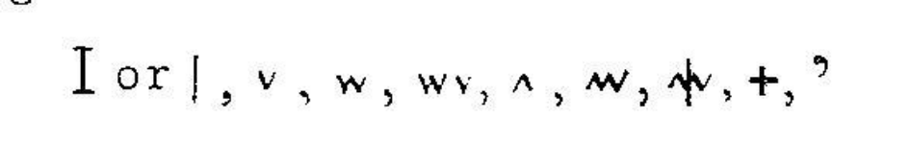
The mordent is a rapid execution to the lower note. Depending on the rhythmic value of the long note, there could be just one alternation or several, but they should always be played quickly and on the beat. Like trills, vary the speed depending on the character of the movement.

TURNS

Also known as a gruppetto or Doppelschlag became very popular in the second half of the 18th century. It could be notated as three ascending grace notes or with an inverted turn sign. It could be placed between two notes or over a note. It helped to smooth out the transition between repeated notes such as in this example from Quantz’s Concerto in G Major, Arioso.

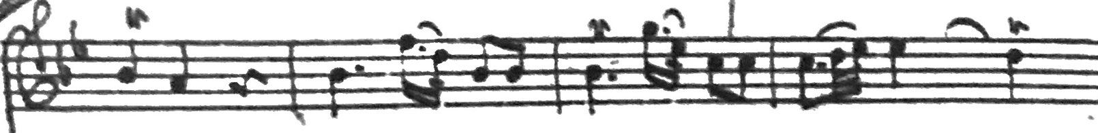
[Original manuscript]
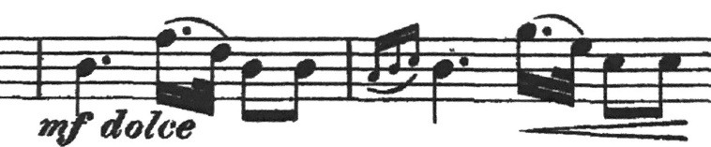
[Pub. By Cundy-Bettony edited by Wilhem Barge]

When placed over a note it consisted of 4 notes, starting on the main note, then the note above the main note, the main note itself, the note below the main note, returning to the main note.

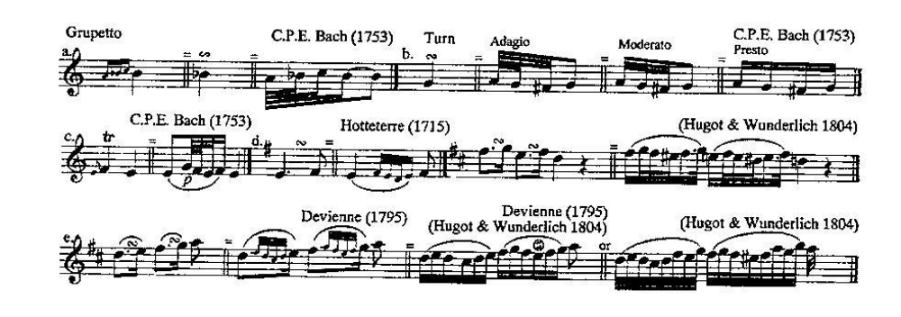

A turn can be very effective at the end of a long trill and was expected in most cases.

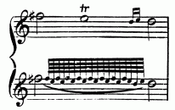

♬ PRACTICE FOCUS

- Get a trill chart. James Pellertie’s A Modern Guide to Flute Fingerings is a must for every flutist. There are many online, too. Fingercharts app is very good to have on your phone.
- Play through the trill chart with loose fingers; vary the speed of the trill.
- Actually play the etudes in your collections (Andersen, Zachert, Köhler, Altes) that include trills and turns. You will notice a difference in your all around technique.

Some considerations in Mozart’s music

As music evolves throughout the mid-18th century, we hear and notice in the music less polyphony and more emphasis on melody. Hamonic movement is slower and underlying accompaniments are simpler. This is referred to as galant music. The performer of this time would still be familiar with all the stylistic practices we have mentioned—unglued notes, trills at cadences utilizing the appoggiatura, gruppetto, and strength of beat.

I’d like to mention a few of these ideas as it relates to Mozart’s Concerto in G Major, K. 313.

- The most common ornament is the appoggiatura both long and short. It can be difficult to determine which is which, but generally you can determine them by their value such as half note, quarter note, eighth note, sixteenth note.
- Rules for execution similar to earlier music, but short appoggiaturas would often be performed slightly before the beat, or quickly on the beat like a snap. (See Trevor Wye’s edition below.)

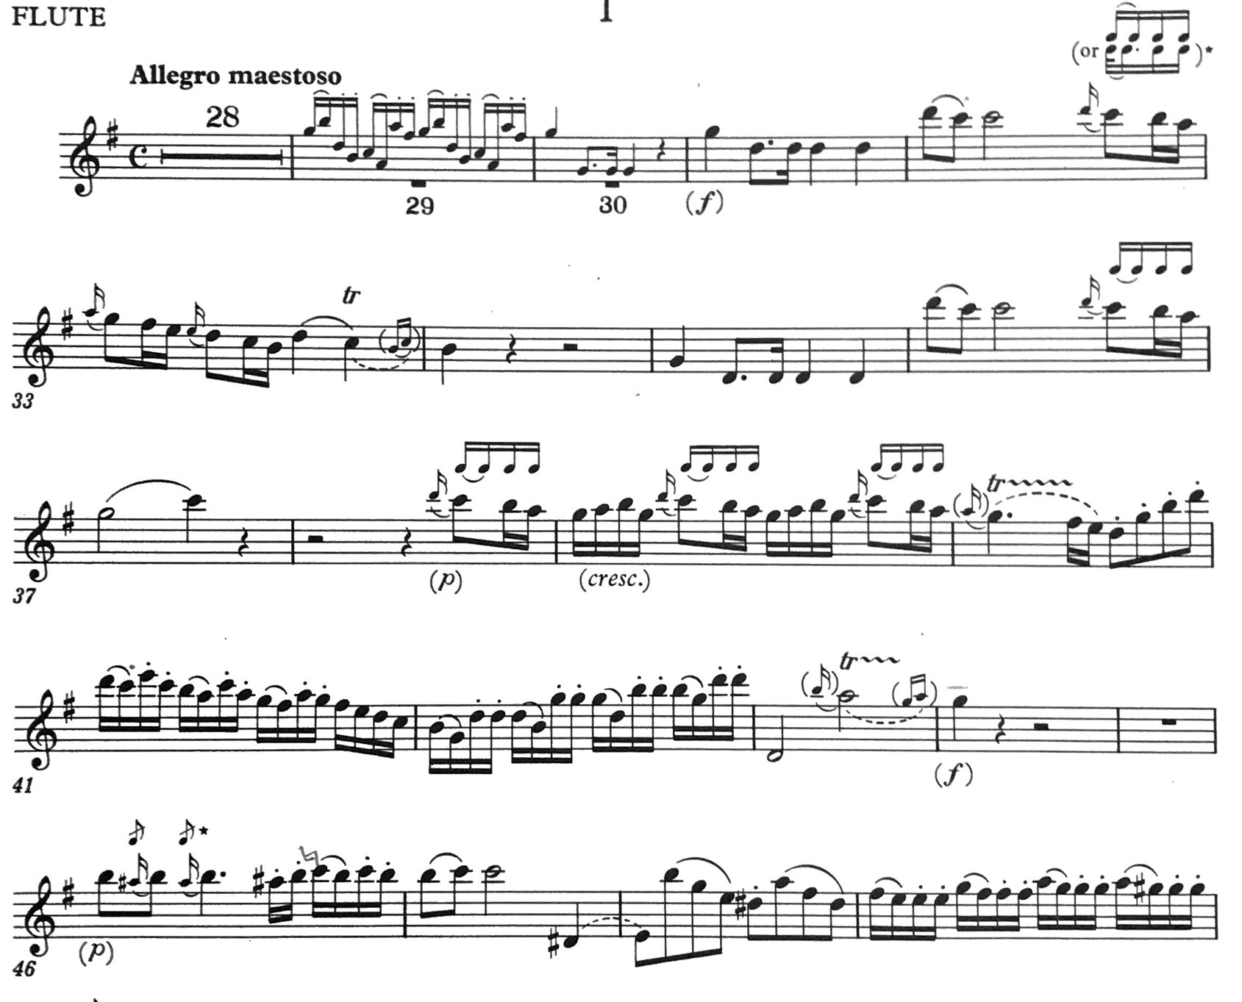

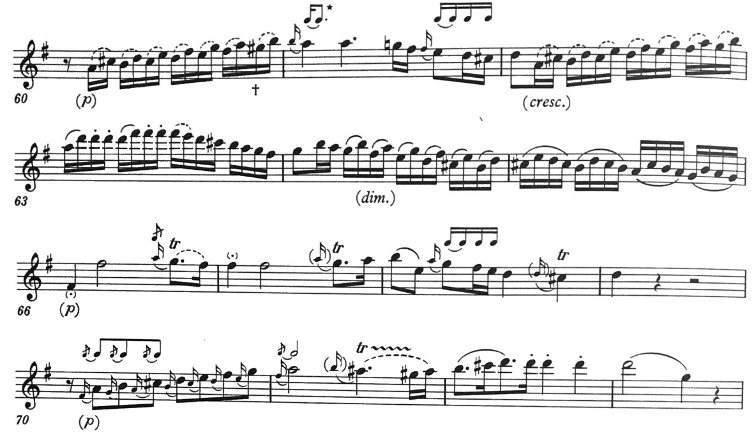

RESOURCES

Brown, Rachel, The Early Flute: A Practical Guide, Cambridge University Press, Cambridge 2002
Brown Rachel, Handel’s Flute and Recorder Sonatas, http://rachelbrownflute.com/_downloads/Handel%20Sonatas.pdf
Lynn, Michael, Ornamentation: An Introduction to the Mordent/Battement, https://americanrecorder.org/docs/AR_winter2020_Education_mordent_FIN2.pdf
Lynn, Michael, Ornamentation: An Introduction to the Trill and Appoggiatura, https://americanrecorder.org/docs/AR_Fall2020_Ornaments1_appog_trill.pdf
Quantz, Johann Joachim, Versuch einer Anweisung die Flöte traversiere zu spielen, translated by Edward R. Reilly under the title On Playing the Flute, Schirmer Books, New York 1966
Vester, Frans, W.A. Mozart. On the Performance of the Works for Wind Instruments, Brockmans & van Poppel B.V., Amsterdam, 1999.

ARTISTS SPECIALIZING IN PERIOD INSTRUMENTS FOR FURTHER LISTENING

Eva Amsler
Leela Breithaupt
Rachel Brown
Barthold Kuijken
Michael Lynn
Jed Wentz

